Continuous Improvement
  - Key Revision Facts: GCSE Technology

Many modern manufacturers have adopted Continuous Improvement methodologies. Effective continuous improvement requires the whole workforce to work together to find positive ways to make adjustments to save money, time, and resources.

Kaizen
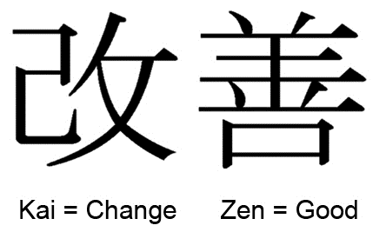
Kaizen is a Japanese term meaning "change for the better" or "continuous improvement." It is a Japanese business philosophy regarding the processes that continuously improve operations and involve all employees. Kaizen sees improvement in productivity as a gradual and methodical process.
There are four types of Kaizen methodologies:

Kaizen Teian
One must always be looking to eliminate the eight forms of waste: Defects, Excess processing, Overproduction, Waiting, Inventory, Transportation, Moving and Non-utilized talent.

Kaizen Events
Kaizen events are typically brief, focused improvement projects where people, including the management team, participate in analyzing their Value Stream Map (VSM) to solve a specific problem.

Kaikaku
Kaikaku describes a process where an entire organization is focused on a revolutionary process transformation. Rather than improving a process, Kaikaku may demand the organization moves to an entirely new process.

Kakushin
Kakushin happens when you move to an entirely new way of doing something. It's about the big break-through that changes everything.

Download
More Key Fact Revision sheets can be downloaded from
www.andrew-seaford.co.uk/revision

Version information
Date | Arthur | Comment
13-Mar-2021 | Andrew Seaford | Initial release.

